**Screenshots**

1. **Check and observe the CPU utilization graph for the EC2 instance**

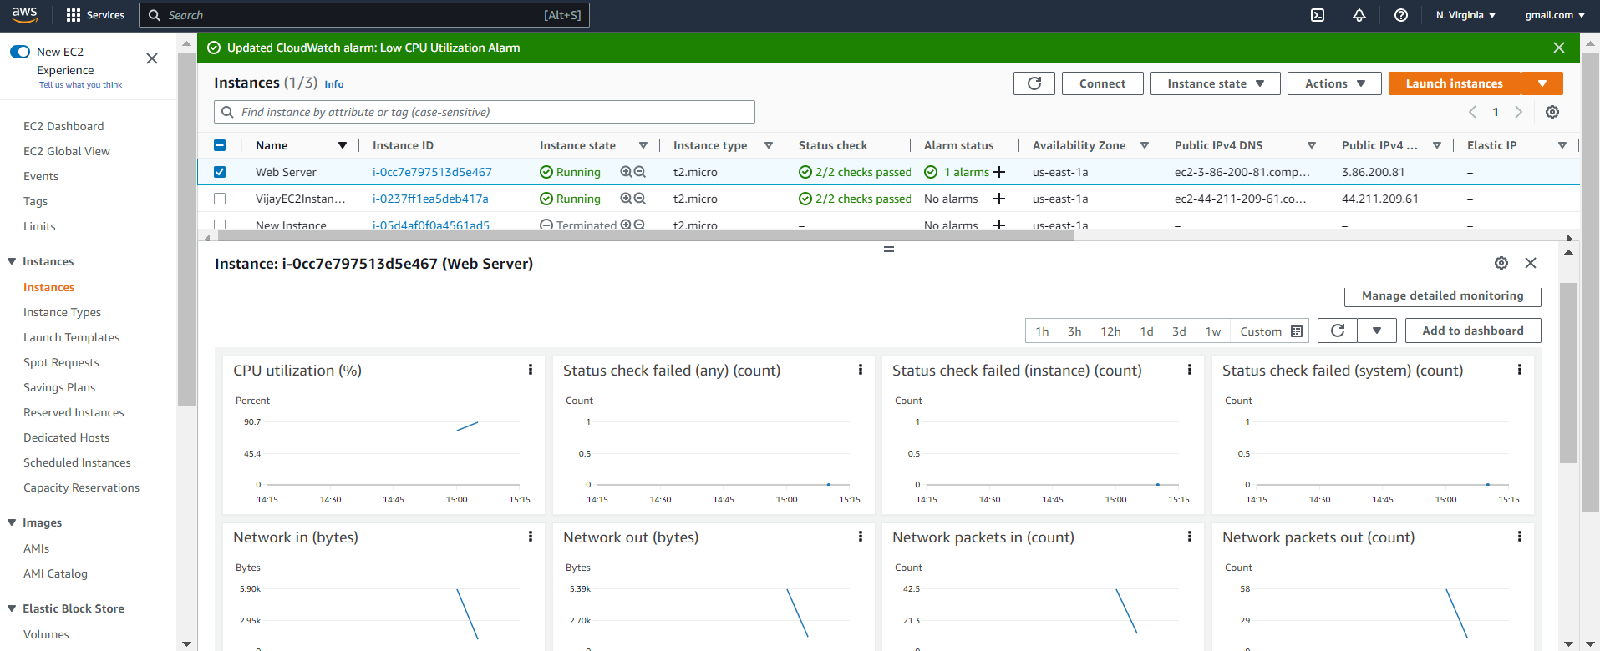

1. **Create and configure a CloudWatch alarm that sends an email notification to HCMonitor@HeavenClassics.com if the CPU utilization goes below the threshold of 3%, consecutively three times for five minutes**

1. **Create an IAM group named Administrator Group and attach the full administrator access policy to the group**

1. **Create a user for an employee of the company who requires administrator access to the company's AWS account, and then add the user to the Administrator Group.**

